Accommodation & Transportation Guide

Hotel Reservation

Hotel reservation is only possible online through worldtkd.simplycompete.com

Rome Midas Hotel Conference****
Via Aurelia,800
00165 Rome

Distance from the "Grand Prix Village": 12 km (20 minutes by car)

Hotel Midas is a luxurious 4-star property located 12.4km (7.7mi) from the centre of Rome. Local tourist attractions such as Aurelio, Villa Doria Pamphili and Trastevere are not far from the hotel. Also easily within reach are Santa Maria in Trastevere, Galleria Nazionale di Palazzo Corsini and Villa Farnesina.

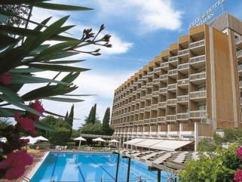
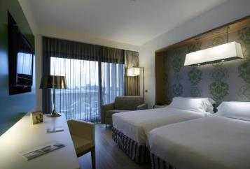
Each of the well-equipped, air-conditioned rooms comes with a bathroom, a hairdryer, a minibar fridge, free WiFi, a hire safe, a direct dial telephone and toiletries.

PRICES
Single room €160,00
Twin/Double €180,00
Triple €190,00

All prices are per room per night.

Breakfast and VAT included.
Art Card (free entrance to the most important Roman Museums) included.
Transportation from/to the airport and Hotel included.
Transportation from/to the Hotel and the "Grand Prix Village" included.
City tax (€6,00 per person per night) not included.
Supplement lunch or dinner in Hotel € 22,00 + 10% VAT (€24,20)

Deadline for Hotel reservation: May 10th 2018

Payment is only possible by Bank transfer

Account Details:

FITA - Federazione Italiana Taekwondo

Banca Nazionale del Lavoro
IBAN: IT08L0100503309000000009477
SWIFT BIC: BNLIITRR

Person in charge for reservation:
Marco Mazzi “ Travel Manager for FITA” and Booking staff.
Email: accommodation@romagrandprix.it
Tel : +393440283617, +393498605690, +393483824239

Transportation

Transport reservation is only possible online through worldtkd.simplycompete.com

Transportation (Airport - Hotel - Sport Venue, Sport Venue -Hotel - Airport) will be provided free of charge ONLY for teams who has reserved the hotel through the Organizing Committee.

Ground transportation (Hotel - Venue- Hotel) will be provided free of charge ONLY for teams who have reserved the hotel through the Organizing Committee.

Airport information

Fiumicino Airport - Main Airport

Fiumicino “ Rome” Airport Skytrax and ACI, airport-service quality certification institutes, reward Leonardo da Vinci airport with the “World’s Most Improved Airport” and “Airport Service Quality Award” accolades. 5 Terminal far 30 minutes to Rome city center “connected by train directly.”, and 20 minutes to the “Hotel Midas”
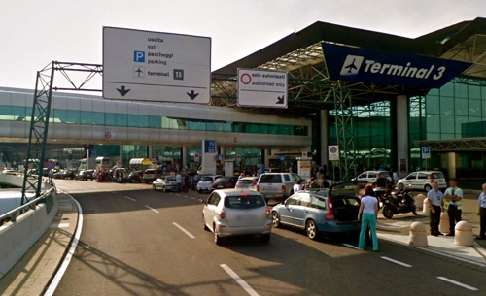

Ciampino - Secondary Airport

Ciampino–G. B. Pastine International Airport (IATA: CIA, ICAO: LIRA) or simply Rome Ciampino Airport, is the secondary international airport of Rome, the capital of Italy, behind Leonardo da Vinci–Fiumicino Airport. It is a joint civilian, commercial and military airport situated 12.0 km south southeast of central Rome and 40 minutes to the “Hotel Midas”

- in case of arrive to “Ciampino Airport” please contact the O.C.:
Email : transportation@romagrandprix.it
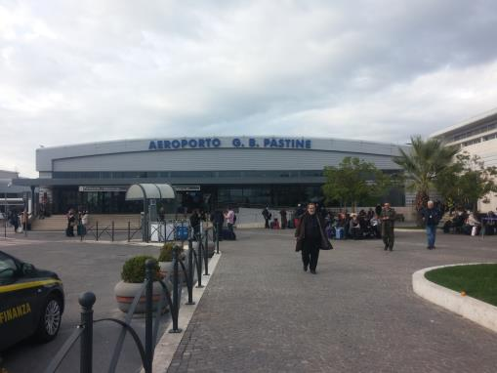
Tel : +393440283617, +393498605690, +393483824239

Signature of The MNA President

